

AI Library App Final Report
Title Page
AI Library App: Implementation of an AI-Supported Digital Library Information System
Course: ICT 301 (Section 131)
Instructor: Billel Arbaoui
Submission Date: 28 April 2026
Team Members
Phyo Wai Aung (6804825)
Yan Naing Kyaw (6804826)
Aung Kyaw Soe Htet (6509667)
Wai Yan Pyae Sone

Table of Contents
Introduction
- Information System Planning
- System Analysis
- Information System Design
- Information Systems Development
- Testing in Information Systems
- System Deployment
- Maintenance Troubleshooting
- Usability Evaluation
- Applying User-Centered Design to an Information Systems Project
- Project Management Information System
- Conclusion

1. Introduction
The system developed in this project is theÂ AI Library App, a web-based digital library information system designed to improve the process of book discovery and selection. The system enables users to browse books, search by title or topic, access detailed information about each book, save books for future use, and obtain recommendations from an AI assistant. Unlike a conventional digital library, this system combines structured catalog access with AI-supported assistance in order to provide a more interactive and helpful experience for users.
The project addresses a common problem in online book platforms, where users often find it difficult to identify the most suitable book, especially when they do not know the exact title they need. In such situations, ordinary search functions may not be sufficient to support effective decision-making. Therefore, the AI Library App was designed and implemented to provide both direct access to book information and additional recommendation support through AI.
This project is closely related to key course topics, including information system planning, system analysis, system design, development, testing, deployment, maintenance, and usability evaluation. The final outcome demonstrates not only conceptual understanding but also the implementation of a working information system that responds to an actual user problem.

2. Information System Planning
The planning stage established the overall direction of the AI Library App project by defining its scope, goals, and implementation timeline. The primary objective was to develop a digital library system that would support both traditional book browsing and AI-assisted recommendation. During this stage, the major functions of the system were identified, including authentication, library browsing, search and filtering, book detail viewing, saved books, recent activity, and AI support.
A project timeline was prepared in accordance with the weekly course structure. This allowed the project to be organized into manageable stages, beginning with planning and analysis, followed by design, development, testing, deployment, and evaluation. Such planning was important to ensure that implementation could proceed in a logical and efficient manner.
Technology selection was also part of the planning phase. React and Vite were selected for the frontend, Node.js and Express for backend processing, Supabase for authentication and data storage, and Gemini API for AI-powered recommendations. These technologies were chosen because they were appropriate for the objectives of the project and feasible within the given timeframe.
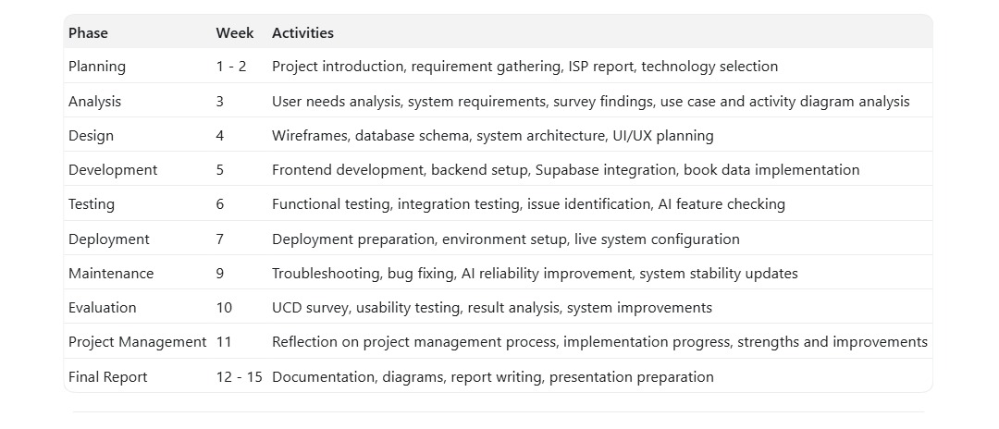
Figure 1. Project timeline table.

3. System Analysis
The system analysis phase aimed to identify user needs, system requirements, and the main problems that the AI Library App should address. To support this phase, user-focused methods such as surveys and observation were employed. The purpose of these methods was to understand how users search for books, what difficulties they face when using digital libraries, and what features they expect from a system enhanced by AI.
The analysis findings revealed that users often experience difficulty when they search by topic rather than by exact title. In many cases, they require support in determining which books are suitable for beginners, which books are practical, and which resources are most relevant to their learning objectives. These results indicated that the system should not function solely as a searchable catalog, but also as a guidance tool for book selection.
Based on the findings, a set of functional requirements was established. These included user login, book browsing, search and filtering, access to detailed book information, saving books, viewing recent activity, and receiving AI-based recommendations. Non-functional requirements included usability, responsiveness, consistency, and clarity of presentation. These requirements directly informed the implementation of the final system.
In addition, the survey findings helped determine which features should be prioritized during implementation. Because users needed better support in choosing books, the AI Assistant and the Book Detail Page became especially important parts of the system. This meant that the implementation phase focused not only on storing and displaying books, but also on improving recommendation quality and the clarity of book information.
To represent the system requirements more clearly, UML diagrams were used during the analysis stage.
Use Case Diagram
The use case diagram illustrates the major interactions between the user and the AI Library App. It includes the key system functions such as signing in, browsing books, searching for books, viewing book details, saving books, viewing saved books and recent activity, and requesting recommendations from the AI assistant. This diagram helped define the system scope and ensured that the implemented functions reflected identified user needs.
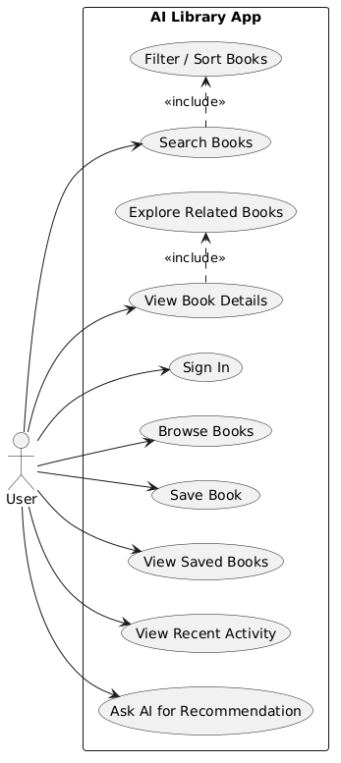
Figure 2. Use case diagram of the AI Library App.

Activity Diagram
The activity diagram illustrates the main workflow followed by the user within the system. It begins with opening the application and signing in, continues through browsing or searching for books, viewing details, saving books, and using the AI assistant, and may end with reviewing saved books or recent activity in the profile area. This diagram was useful for understanding the sequence of user activities and the relationship between core features.
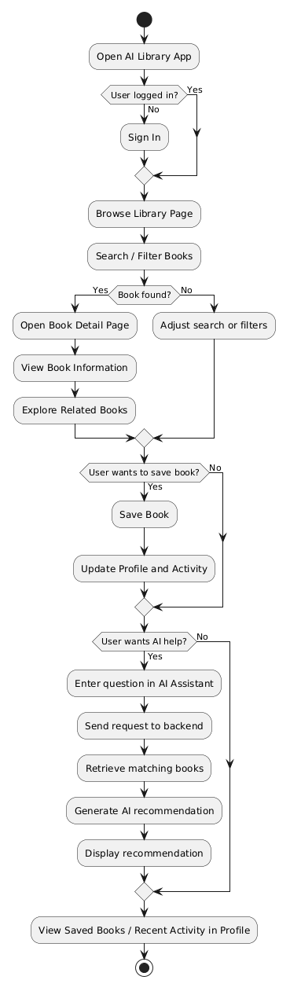
Figure 3. Activity diagram showing the workflow of the AI Library App.

4. Information System Design
The design phase translated the requirements identified during analysis into the structural and visual form of the AI Library App. Wireframes were prepared to guide the design of the Library page, Book Detail page, AI Assistant page, and Profile page. These wireframes supported early planning of layout, navigation, and information hierarchy before implementation began.
The Library page was designed as the primary entry point of the system and includes search, filtering, sorting, book cards, and save actions. The Book Detail page was designed to provide complete information about an individual book, including metadata, description, file availability, and related books. The AI Assistant page was designed to support natural-language interaction for recommendation purposes. The Profile page was designed to provide access to saved books and recent activity.
Wireframes were valuable because they made it possible to test the arrangement of content before development started. The Library page wireframe focused on search visibility and easy browsing, while the Book Detail Page wireframe focused on clearer decision-making through complete book information and related books. The AI Assistant and Profile wireframes were designed to support personalization, continuity, and a smoother user journey across the system.
In addition to interface wireframes, system modeling was also applied during the design phase. UML diagrams were used to explain system interaction and architecture more clearly.
Sequence Diagram
The sequence diagram describes how the system components interact over time. In the AI Library App, it shows how the user submits a request through the frontend, how the backend processes the request, how Supabase supplies book or user data, and how the Gemini API generates AI-supported recommendations. This diagram is valuable for explaining communication between system elements during operation.
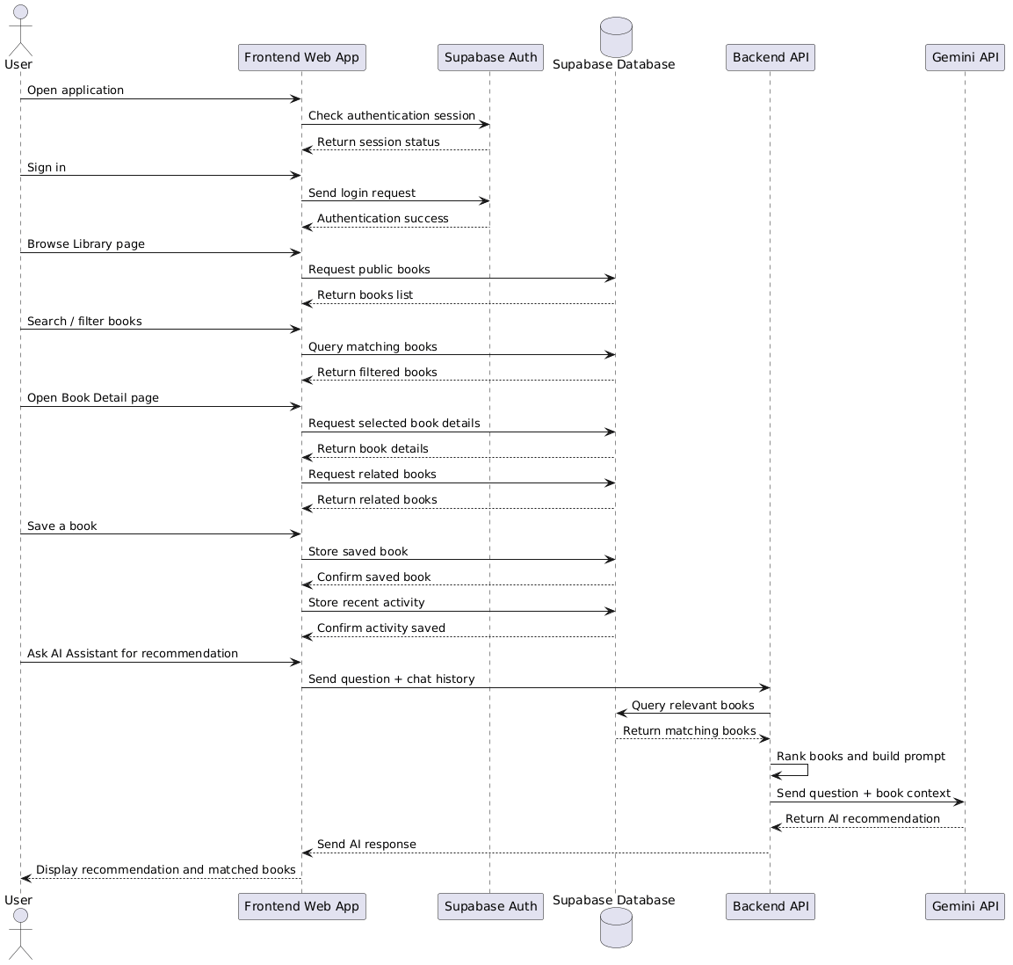
Figure 4. Sequence diagram of the AI Library App.
Component Diagram
The component diagram presents the overall architecture of the AI Library App. It identifies the principal components of the system, including the web user interface, backend application server, AI assistant controller, book search manager, profile manager, database, and Gemini API. This diagram is important because it provides a clear overview of the structural organization of the system.
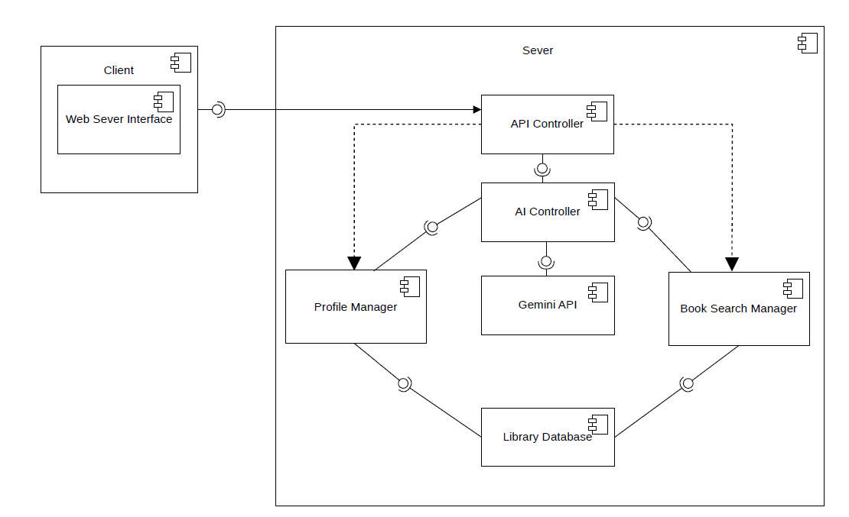
Figure 5. Component diagram of the AI Library App.
The design phase ensured that the system was both visually organized and technically structured before development commenced. This reduced implementation uncertainty and provided a clear foundation for building the final application.

5. Information Systems Development
The development phase focused on transforming the design into a functional system. The frontend was implemented using React and Vite, while the backend was developed with Node.js and Express. Supabase was used for authentication and storage of book and user-related data, and Gemini API was integrated to provide AI-based recommendation capabilities.
A major challenge encountered during development involved ensuring that the AI assistant generated recommendations from the actual library catalog rather than responding as a general-purpose chatbot. This challenge was addressed by implementing backend logic that first retrieves and ranks relevant books from the database before sending contextual information to the AI model. This approach improved the relevance and practicality of AI-generated responses.

6. Testing in Information Systems
Testing was conducted to verify that the AI Library App functioned correctly and was ready for implementation. Functional testing was carried out on major features, including login, book browsing, search and filtering, book detail viewing, saving books, recent activity, and AI-based recommendations.
The results showed that the core features of the system were operating successfully. However, some issues were identified, particularly in AI recommendation quality and the synchronization of saved books and recent activity. These issues were progressively resolved through debugging and refinement. Testing therefore played an essential role in ensuring that the system was sufficiently stable for deployment.
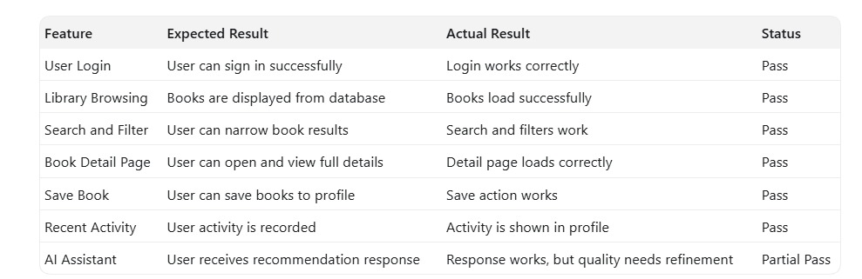
Figure 6. Functional testing results table.

7. System Deployment
The deployment phase involved making the system available outside the local development environment. The frontend was prepared for deployment using Vercel, while the backend was configured for deployment using Render. Supabase remained responsible for live authentication and database services.
One challenge during deployment involved the configuration of environment variables and integration with external services, particularly Supabase and Gemini API. This issue was resolved by verifying configuration values carefully and using health checks to confirm backend connectivity. Following deployment, the system was able to run successfully in a live environment, although AI availability still depended partly on external API demand.

8. Maintenance Troubleshooting
Maintenance and troubleshooting were required after implementation to improve the stability and consistency of the AI Library App. This phase involved identifying issues discovered during later testing or practical use and resolving them in order to improve the system.
One major issue involved the clarity and reliability of AI responses. In earlier versions, recommendations were sometimes too broad or difficult for ordinary users to understand. This problem was addressed by refining the recommendation logic and simplifying the explanation style used by the AI assistant. Additional issues involving saved books and recent activity were also improved so that the system behaved more consistently.

9. Usability Evaluation
Usability evaluation was conducted to assess how effectively real users could interact with the AI Library App. Methods included online surveys, usability testing tasks, and direct user feedback. Participants were asked to perform tasks such as browsing books, searching for topics, opening the Book Detail page, saving books, and requesting recommendations from the AI assistant.
The results indicated that the system was generally useful, but several usability issues were identified. These included limited AI response accuracy, response delays, context-awareness issues, and some weaknesses in the clarity of the Book Detail page. Based on these findings, one significant improvement involved simplifying AI explanations to make them more understandable for general users.
The evaluation results were important because they directly influenced post-implementation improvements. In response to the feedback, the recommendation logic was refined, AI responses were rewritten in simpler language, and the Book Detail Page was improved to present information more clearly. This demonstrated how usability evaluation contributed directly to strengthening the final implementation.
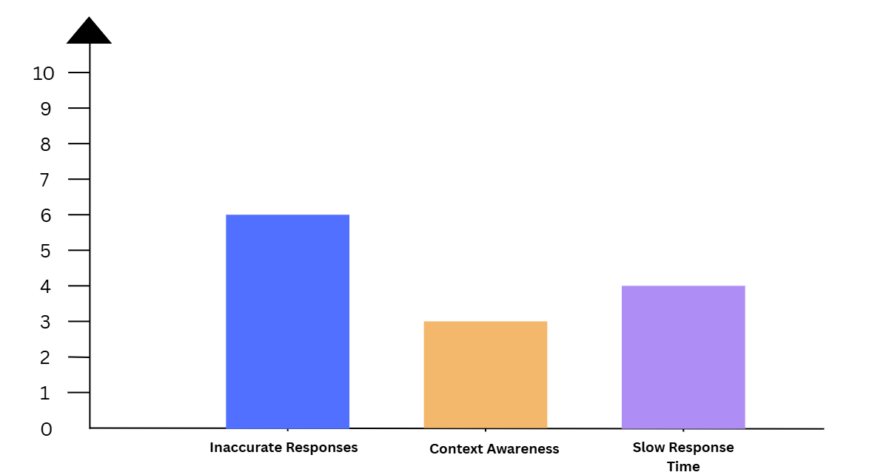
Figure 7. Usability survey result chart for AI Assistant.
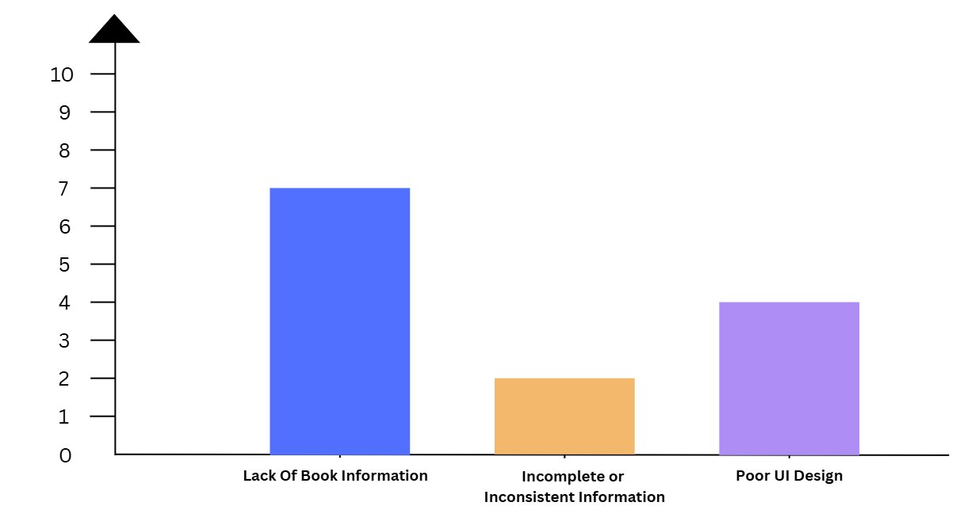
Figure 8. Usability survey result chart for the Book Detail Page.

10. Applying User-Centered Design to an Information Systems Project
User-centered design was applied throughout the development of the AI Library App in order to ensure that the system addressed actual user needs. Each project phase contributed to this objective: planning defined the direction, analysis identified user problems, design transformed those problems into interface solutions, development implemented the features, testing checked functionality, and usability evaluation supported later refinement.
One important challenge was balancing technical complexity with usability, especially in relation to the AI feature. It was not sufficient for the AI assistant to produce technically correct responses; those responses also needed to be relevant, understandable, and useful. By refining recommendation logic and simplifying explanation style, the project was able to overcome this difficulty and align the system more closely with user expectations.

11. Project Management Information System
Project management was carried out using a phased approach that aligned with the weekly course structure. This structure made it possible to organize the work into clear stages, including planning, analysis, design, development, testing, deployment, maintenance, and evaluation.
One notable success in project management was the completion of the main system functions within the planned sequence. These included authentication, library browsing, book detail functionality, profile features, and AI integration. An area for improvement, however, was time allocation for AI refinement and deployment, as these tasks required more troubleshooting than initially expected. Overall, the project management process was effective in supporting implementation.

Figure 9. Project timeline table.

12. Conclusion
In conclusion, the AI Library App successfully achieved its objective of providing a web-based digital library system that helps users browse, evaluate, and discover books more effectively. By integrating real book data, personalized features, and AI-assisted recommendations, the system offers a more supportive and interactive alternative to a traditional digital library interface.
The project demonstrates that successful implementation depends not only on technical development, but also on careful planning, analysis, design, testing, deployment, maintenance, and usability evaluation. Although there remain opportunities for future improvement, particularly in AI quality and deeper book analysis, the project shows that a user-centered information system can be both practical and meaningful.

